**Apartment Guide Project Documentation**

**By:**

**Lama Mohamed Nafei**

**Table of Content**

**I. Introduction**

**Purpose 2**

**Intended Audience and Reading Suggestions 2**

**Project scope 2**

**II. Overall Description**

**Product Features 3**

**Operating Environment 3**

**Design and implementation constraints 3**

**System Features 3**

**III. Software Tools**

**Ruby 4**

**Ruby on Rails 4**

**SQLite 4**

**IV. Database Diagram**

**Users 5**

**Apartments 5**

1. **Introduction**

**Purpose:**

In this site, we will look at help the people to find an apartment that meets their requirements (its price and location).

For customers: it will facilitate the process of searching for an apartment.

For landlords: it will facilitate the process of offering apartments.

**Intended Audience and Reading Suggestions:**

The readers of the project are supposed to be anyone searching for or interested in Ruby on rails, Ruby, sqlite3 R.D.B, web storage applications, web development using Ruby.

The readers should have a basic idea about web development, ruby, Data structures and

R.D.B before reading the documentation.

**Project scope Goals:**

* + 1. Sign Up
    2. Choose if you are landlord or customer to add apartments or browse it
    3. Log In
    4. Add Apartments
    5. Show Apartments data
    6. Search for apartment with specific properties
    7. Click on any apartment he interested in to see it is details and pictures

1. **Overall Description**

**Product Features:**

In our project we can save apartment and show it to the user every user like he need (landlord or customer) and the user can search for specific properties he need to make find apartment easier for him.

Project has a details page that lets users see the details and pictures of apartment he interested in.

Finally, the home page shows some details about us, our web-app, and search bar to search of apartments

**Operating Environment:**

VS code with Ruby framework Ruby on rails as the IDLE.

For the database sqlite3 is used as it is suggested as the best D.B to be used with Ruby on rails, to show tables SQLite studio has been used.

**Design and implementation constraints:**

Constraints in the application are:

* 1. If a email is already used, you should choose new email flash message will appear
  2. Images with jpeg, Png extensions are only allowed no PDF or other when add apartments picture
  3. If a password not strong when sign up or wrong when log in a flash message will appear
  4. If you are sign up as landlords cannot see apartments of another landlord
  5. If you are sign up as customer you can’t add apartments
  6. If you aren’t log in you can’t browse apartment in the web-app

**System Features:**

The program developed to show available apartments in the region to make it easier to find apartments for the client and sell offers for landlords. The program is saving money, effort and time.

1. **Software Tools:**

**Ruby:**

Ruby is an interpreted, high-level, general-purpose programming language which supports multiple programming paradigms.

**Ruby on Rails:**

is a server-side web application framework written in Ruby under the MIT License.

**SQLite Database:**

It is a C-language library that implements a small, fast, self-contained, high-reliability, full-featured, SQL database engine.

1. **Database Diagram:**

**Users:**

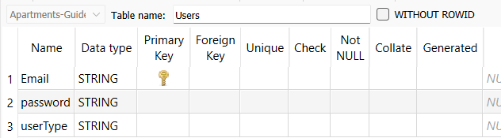

**Apartments:**

